# ITP 499, Fall 2021

# Homework 9 15 points

* Create a *new* Python file. Name *lastname_firstname_hw#.py*
* Create a header using *comments* to display your name and HW information. After that write your Python code.

*#Nitin Kale  
#ITP 499 Fall 2021  
#HW9*Create a Word file with screenshots of your output

* Zip the python file and the Word file. Submit on blackboard.

Our goal is to train a recurrent neural network to translate English sentences to French sentences.

We covered this in detail in lecture 17 of the course.

Use the code covered in class as your starting point. Data files are posted under Lecture 17.

Train your model for at least 20 epochs.

1. Plot the train and validation *loss* curves of the model. (3)

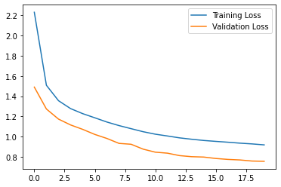

1. Plot the train and validation *accuracy* curves of the model. (3)

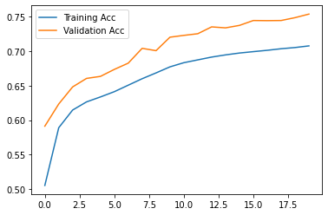

1. After the model is trained, use the model to translate the following sentence into French. (5)

*she is driving a big green truck in paris and California*

**

1. Translate the sentence above using Google translate <https://translate.google.com/> . Compare the two results. (2)

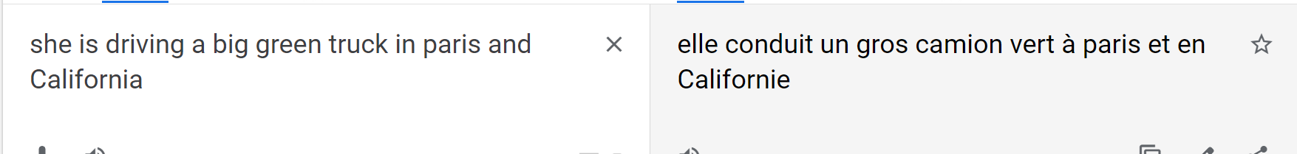

1. What would you do to improve the translation? (2)

Train the model for more epochs. Use the LSTM.